**CSC 255**

**Computer Network**

**Rutvik ManishKumar Patel**

**LAB – 1**

1. **The Basic HTTP GET/response interaction**

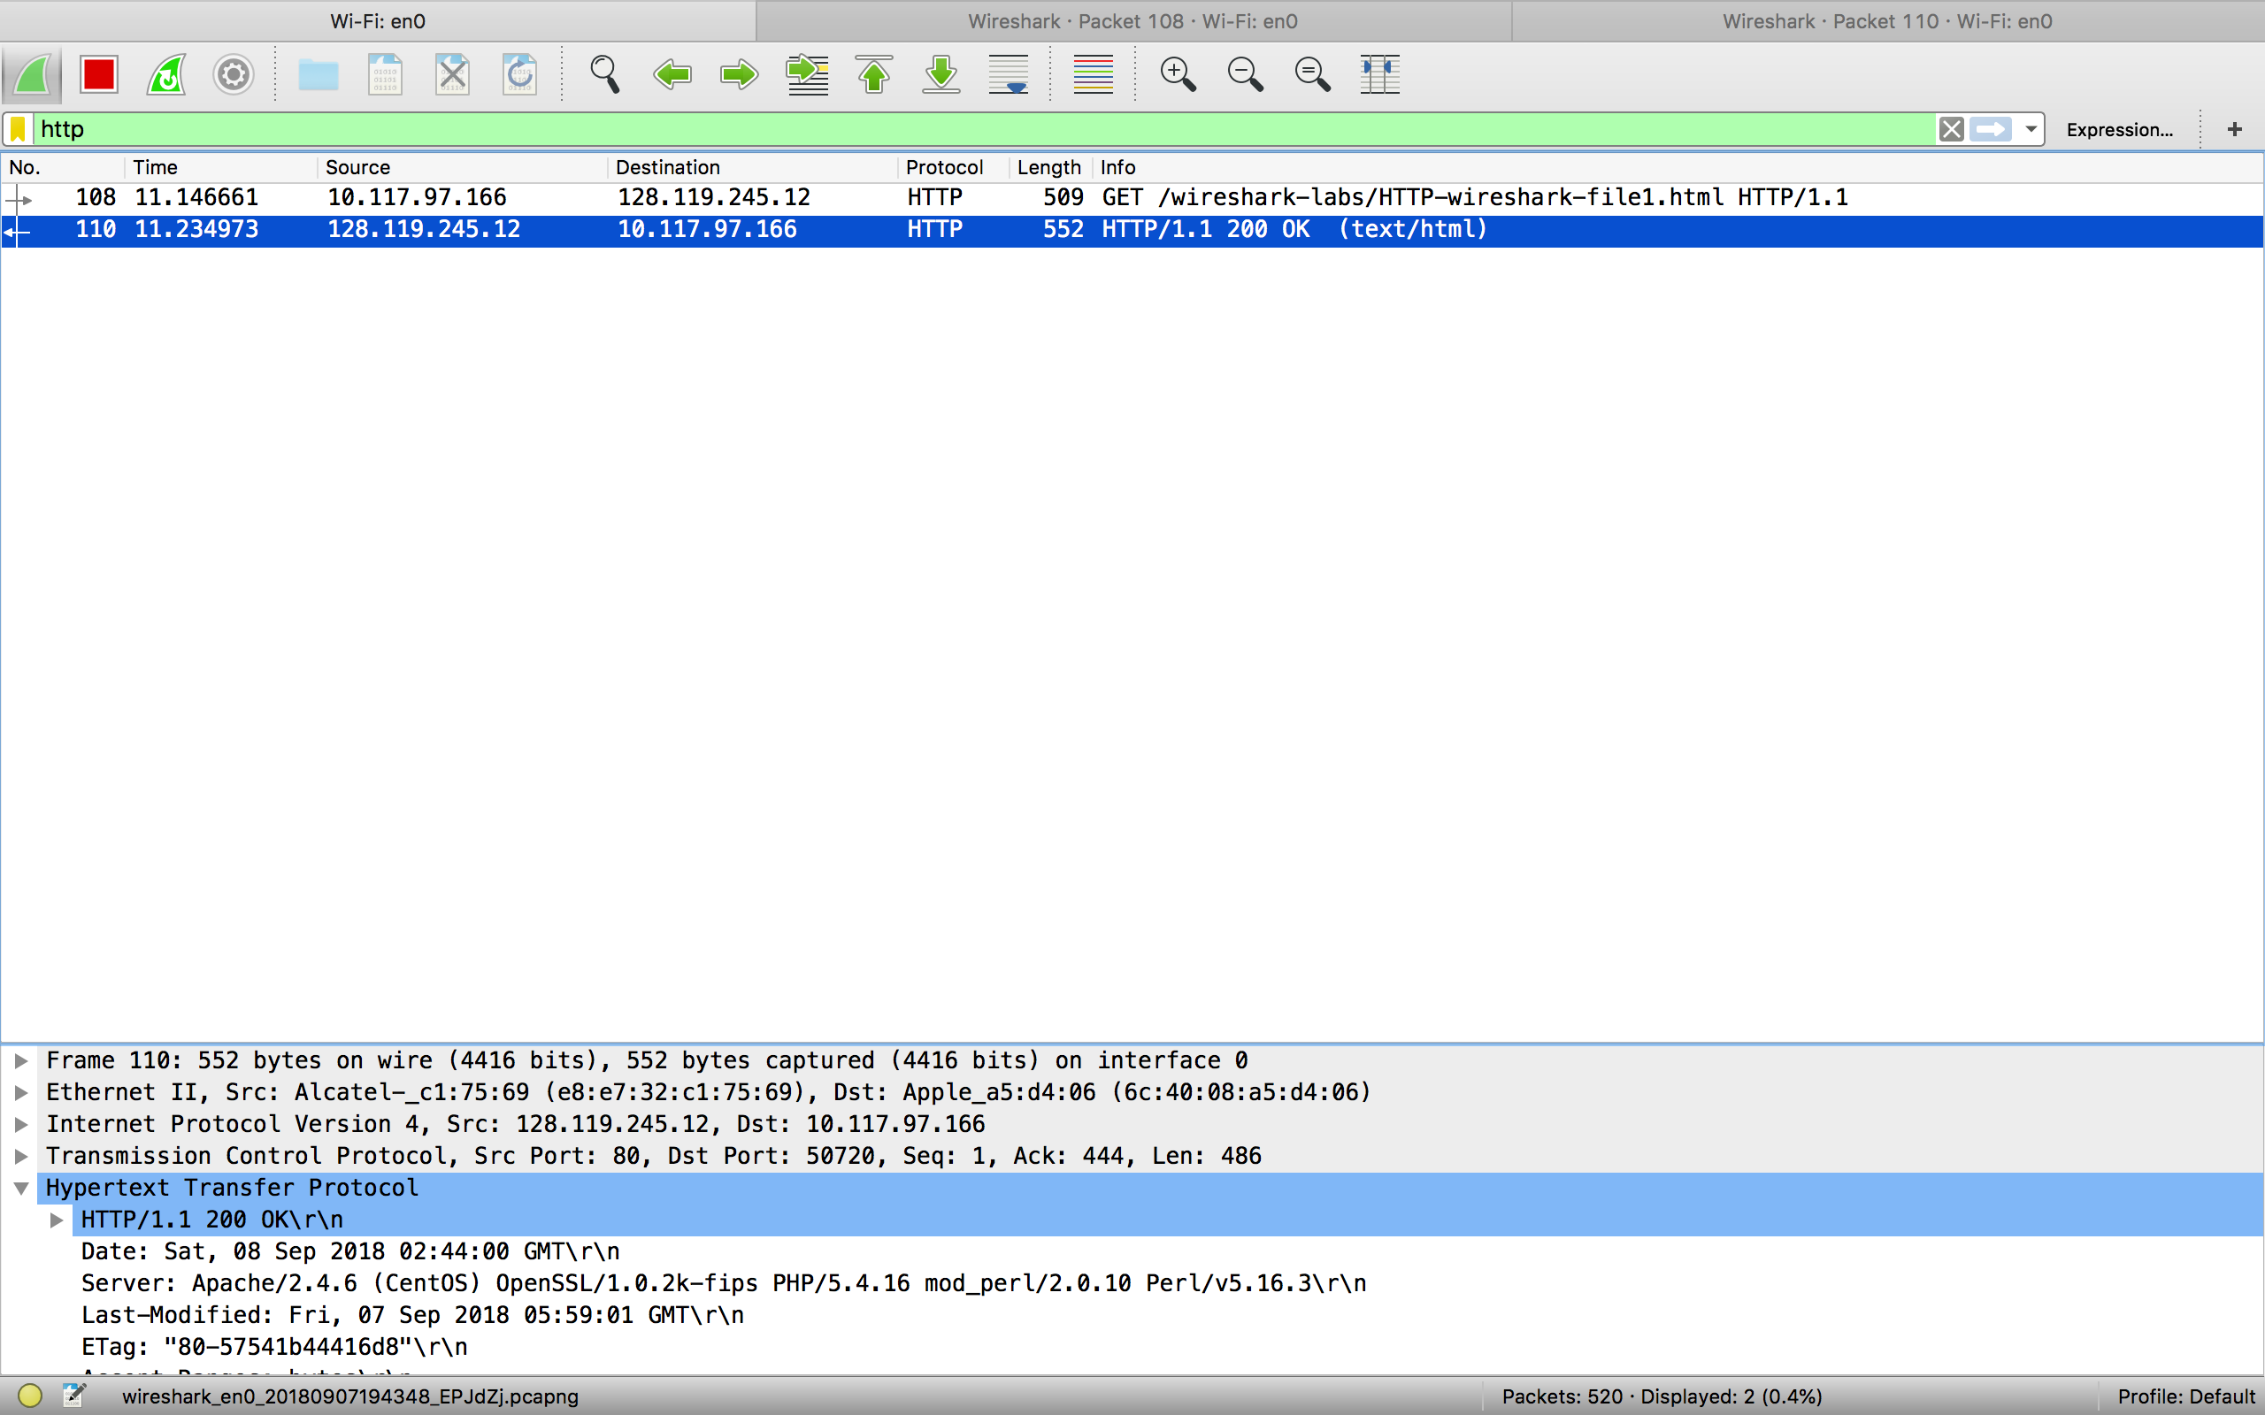

**Answer 1**

**My Brower is running http version 1.1**

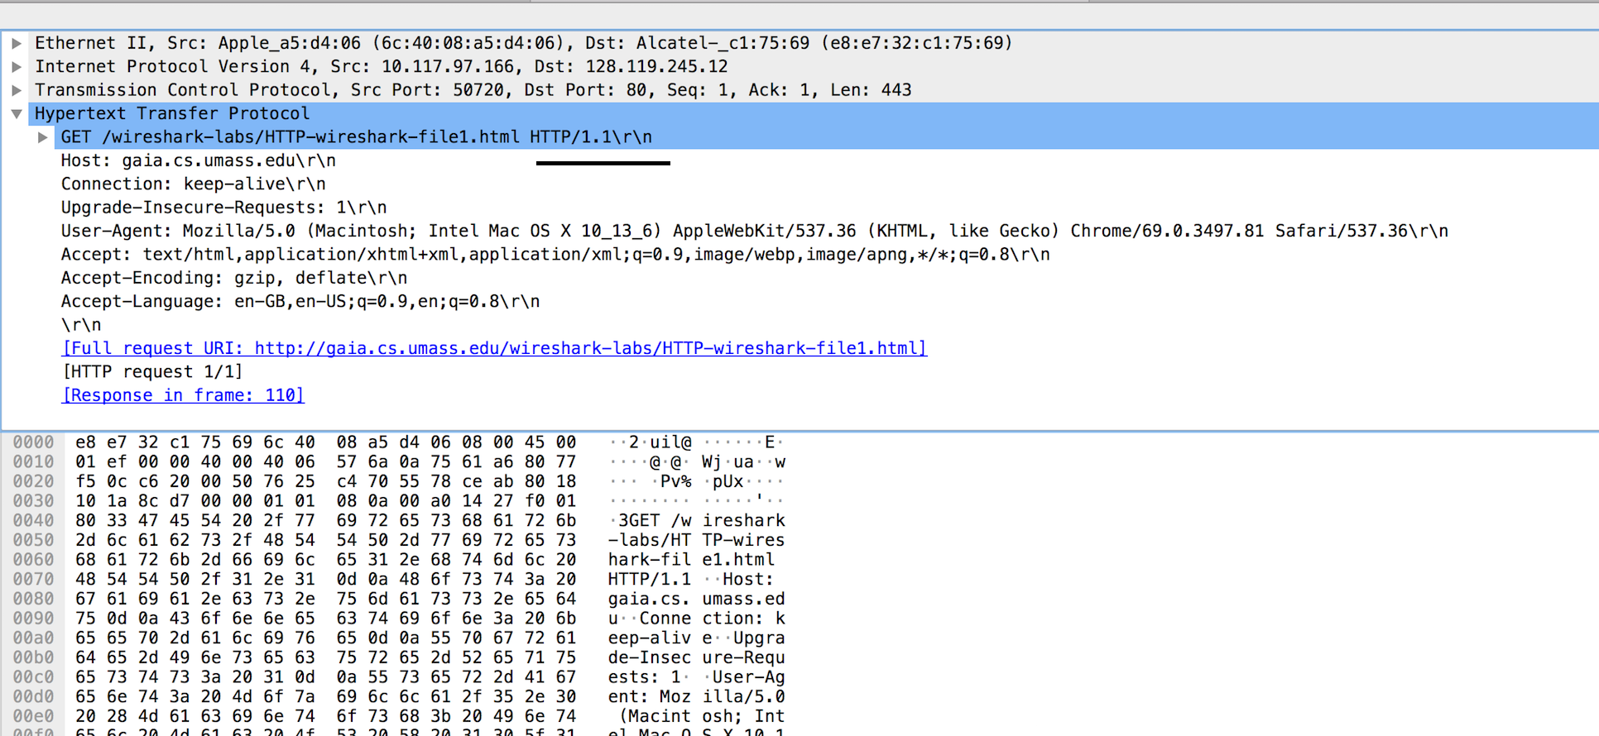

Brower Version

**Server is also running http version 1.1**

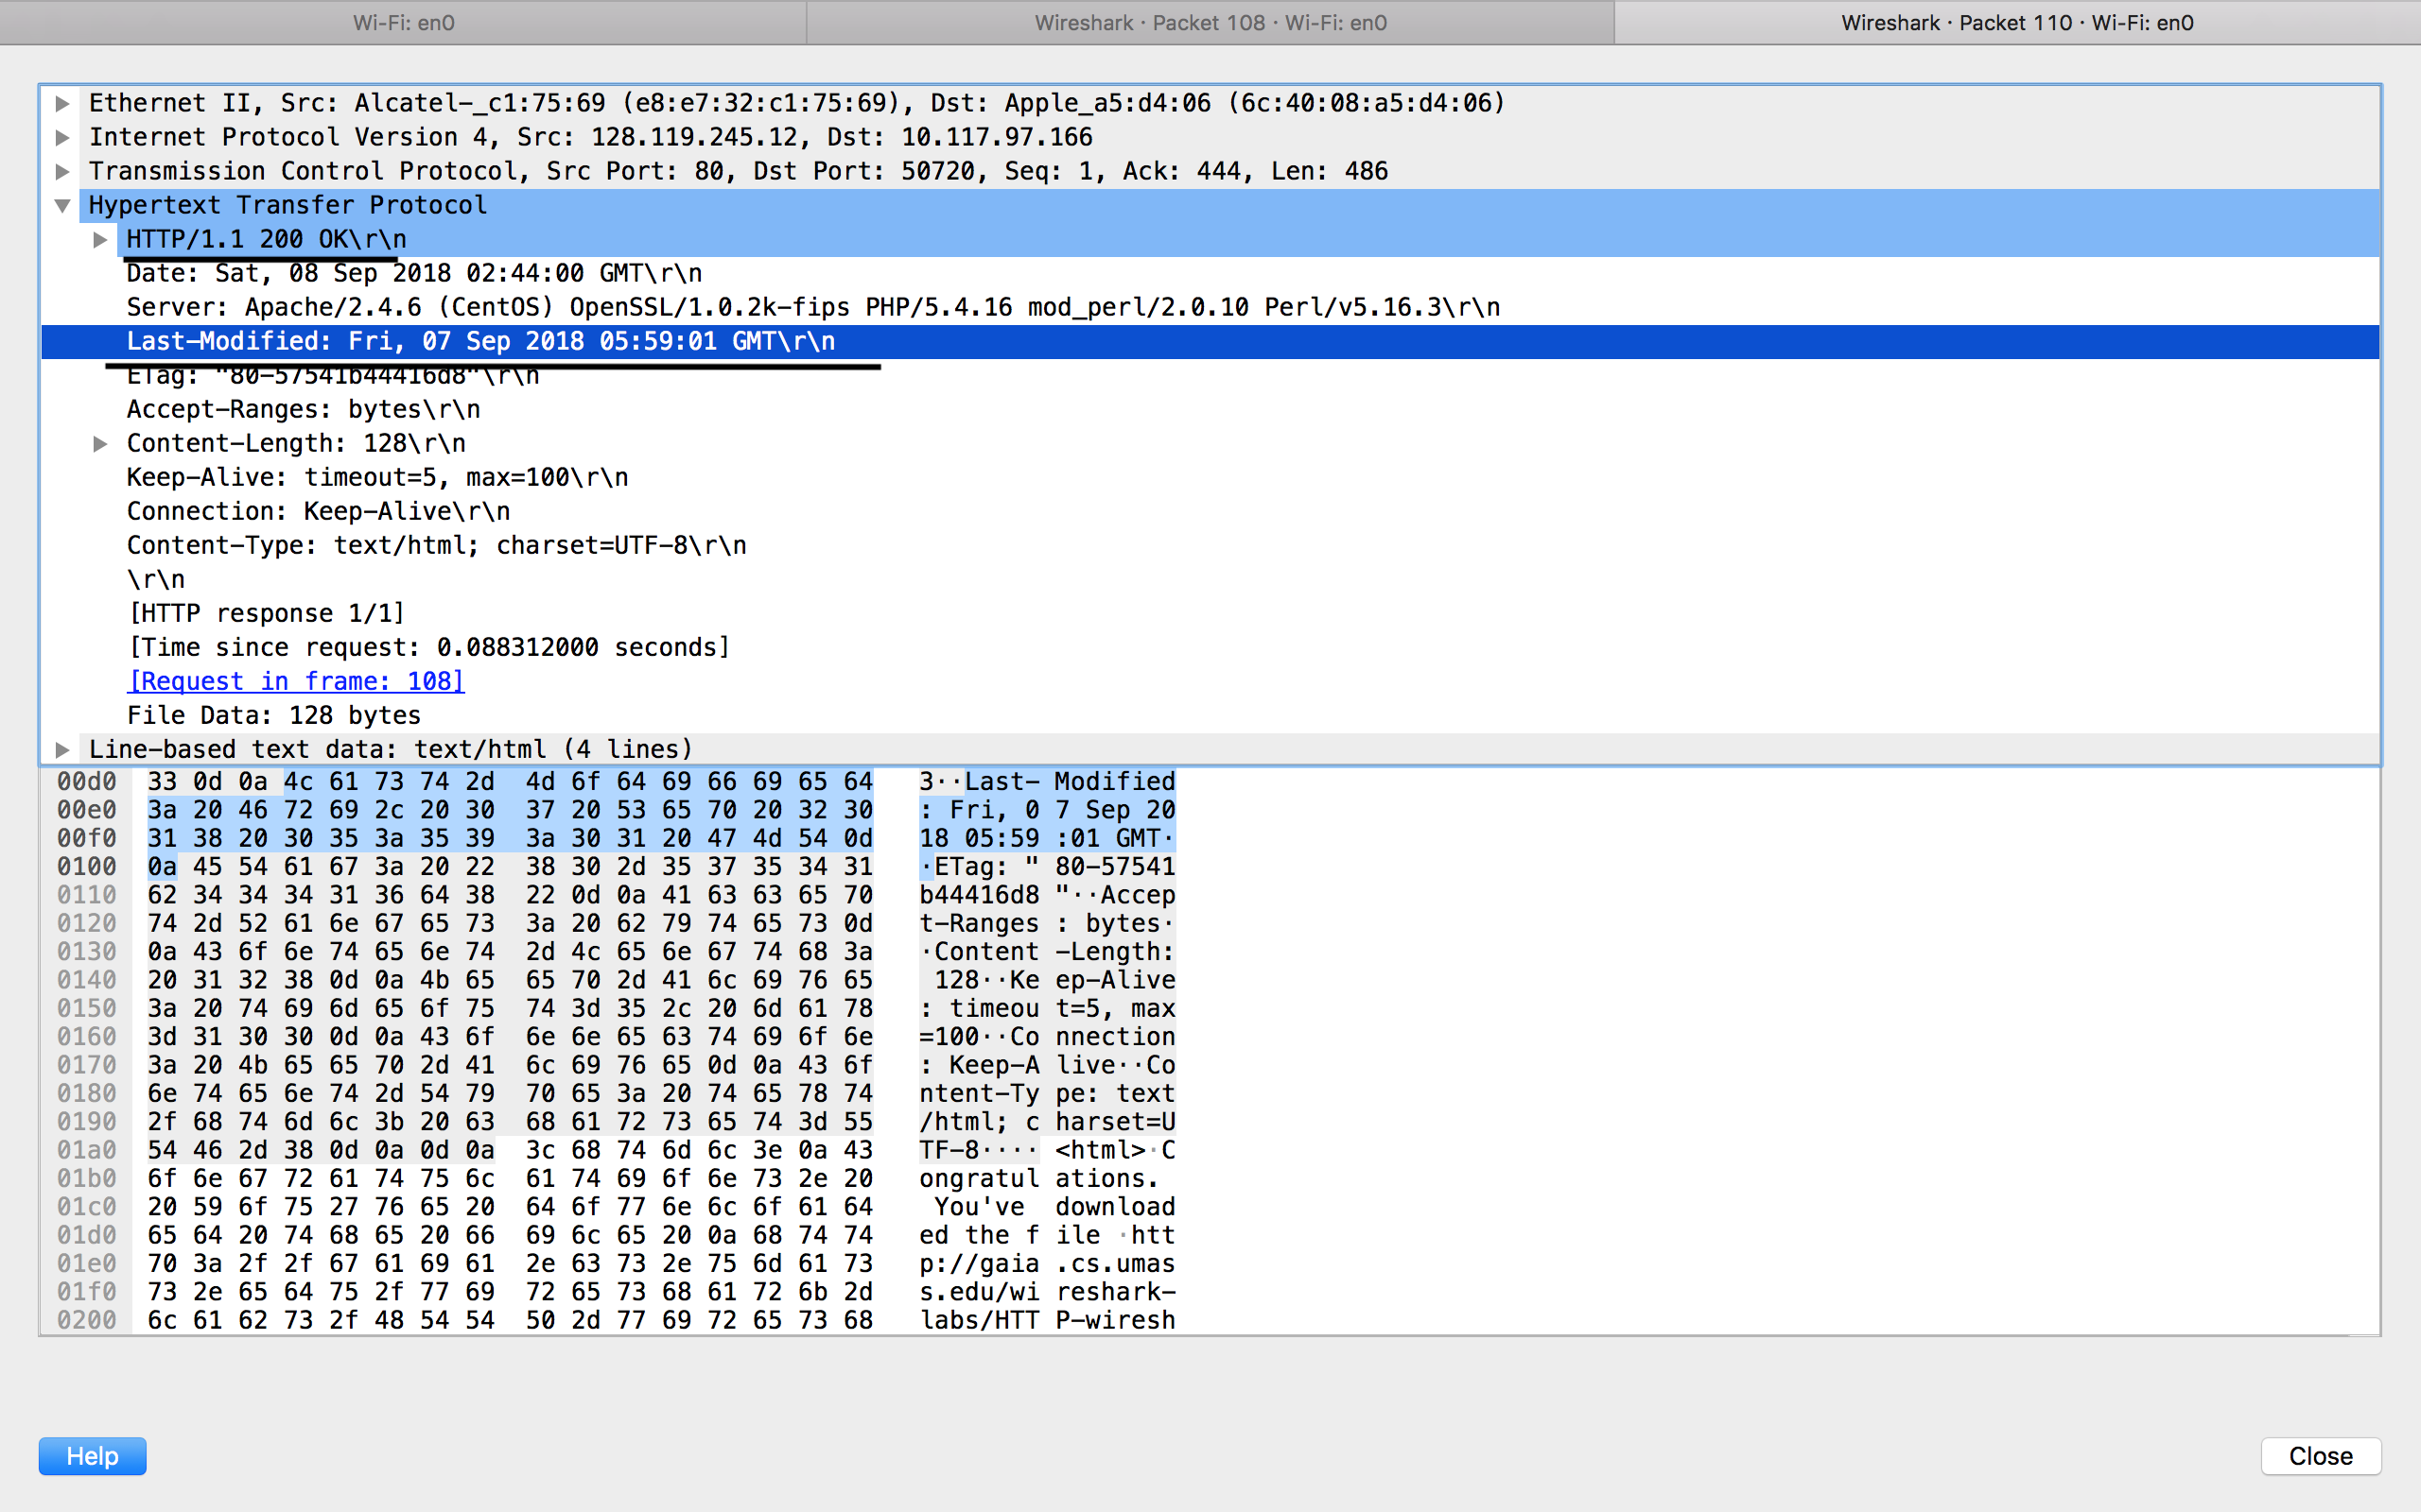

Server Version

**Answer 2**

**It show that it accept en-GB( British English), en-US (American English ) from server**

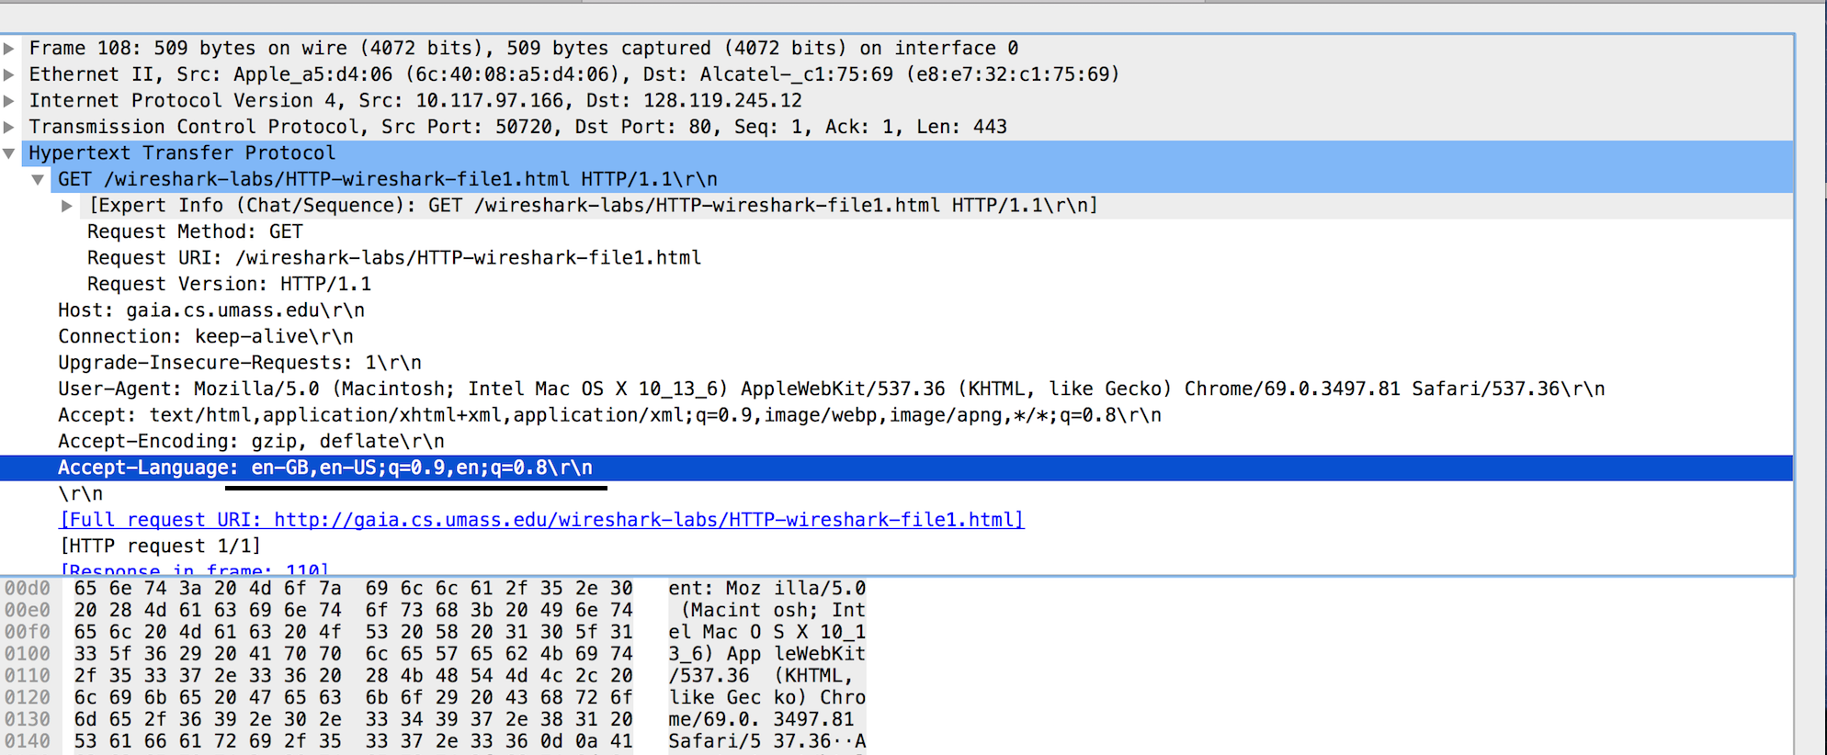

**Answer 3**

**IP address of my computer is 10.117.97.166**

**IP address of the gaia.cs.umass.edu server is 128.119.245.12**

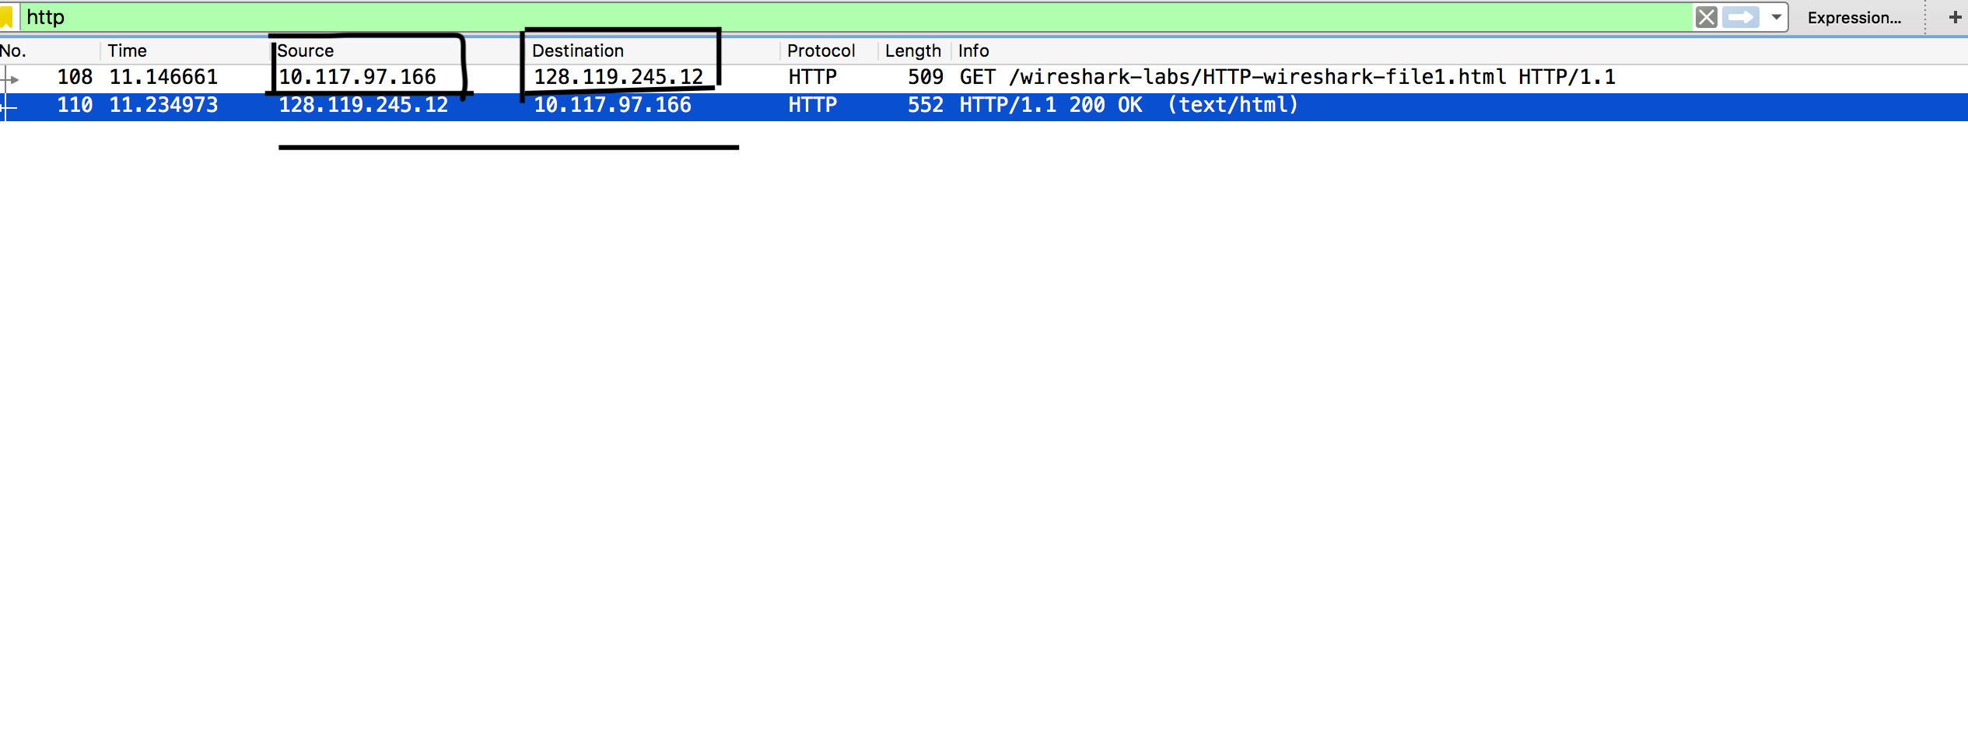

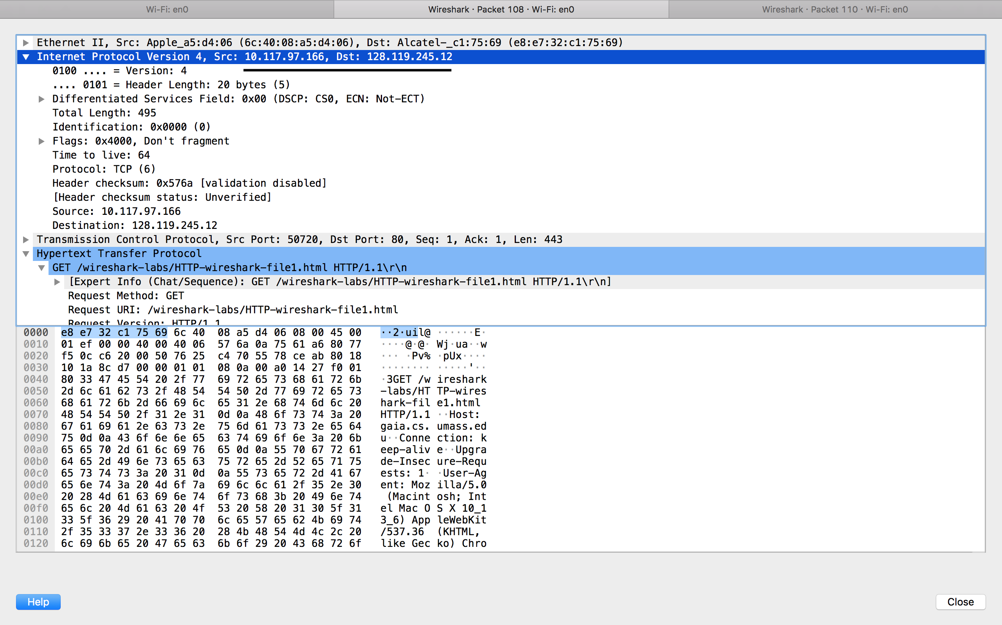

**Answer 4**

**The status code return by the server is 200 OK**

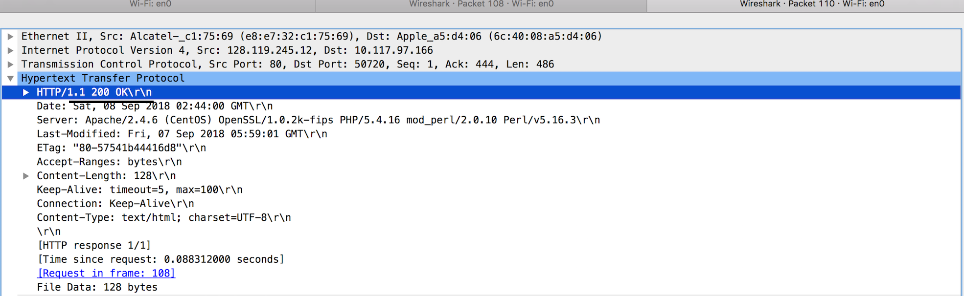

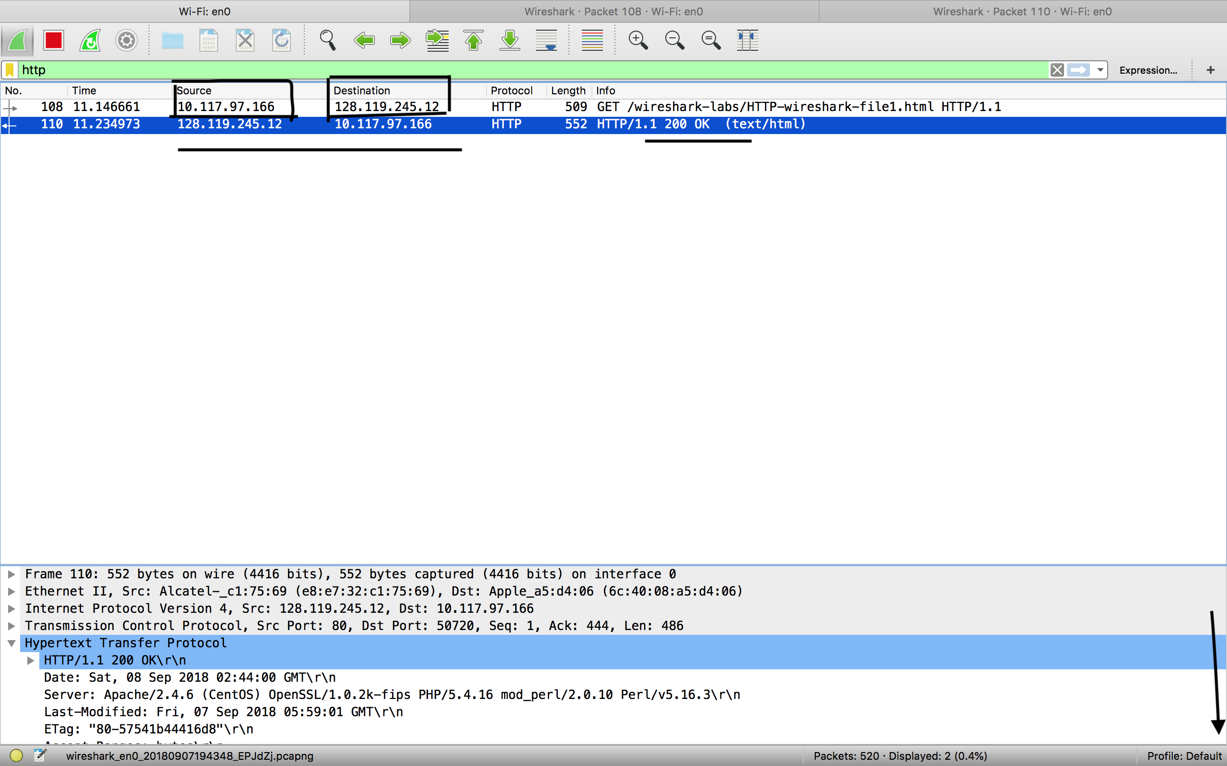

**Answer 5**

**HTML file was last modified on Fri, 07 September 2018 05:59:01 GMT**

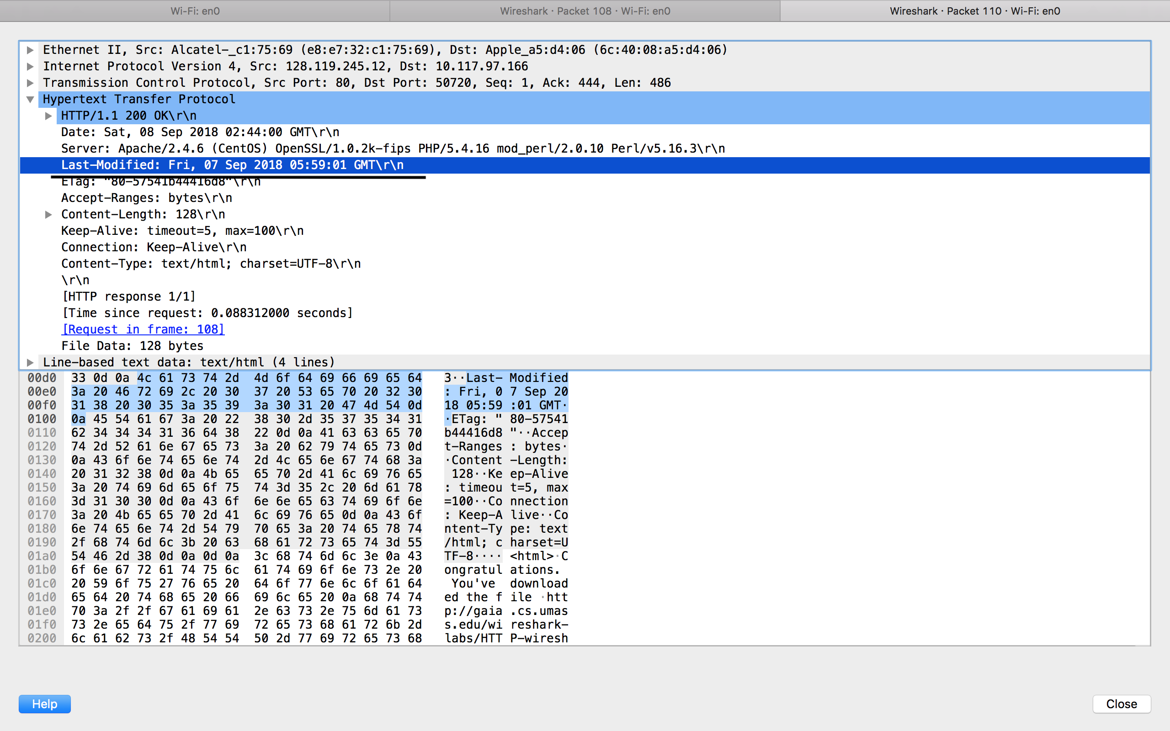

**Answer 6**

**128 bytes of content are return from server**

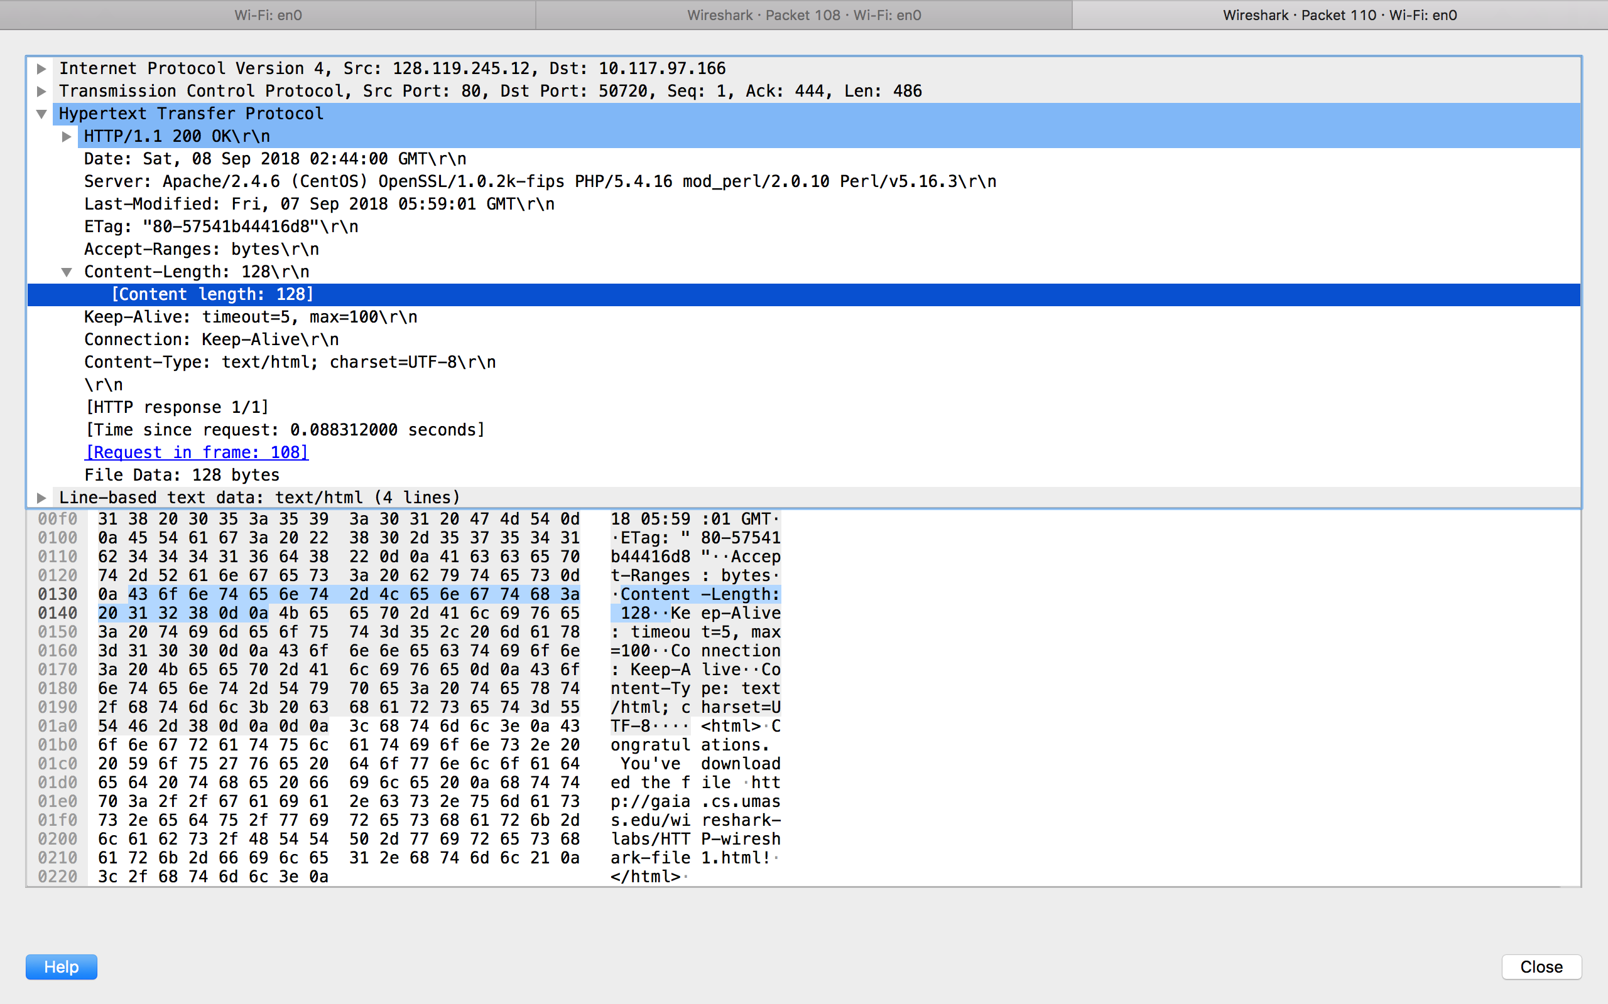

**Answer 7**

**I do not see any different headers between the data.**

1. **The HTTP CONDITIONAL GET/response interaction**

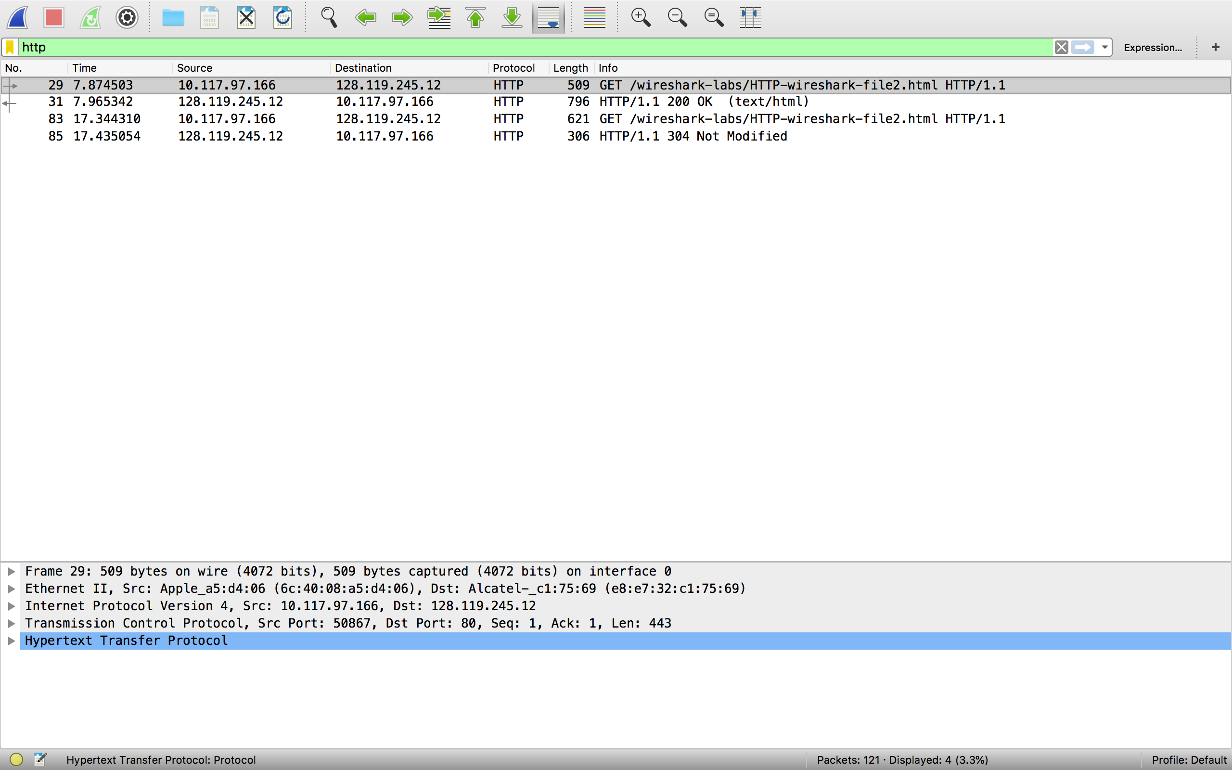

**Answer 8**

**NO There is no IF-MODIFIED-SINCE line in the HTTP GET message**

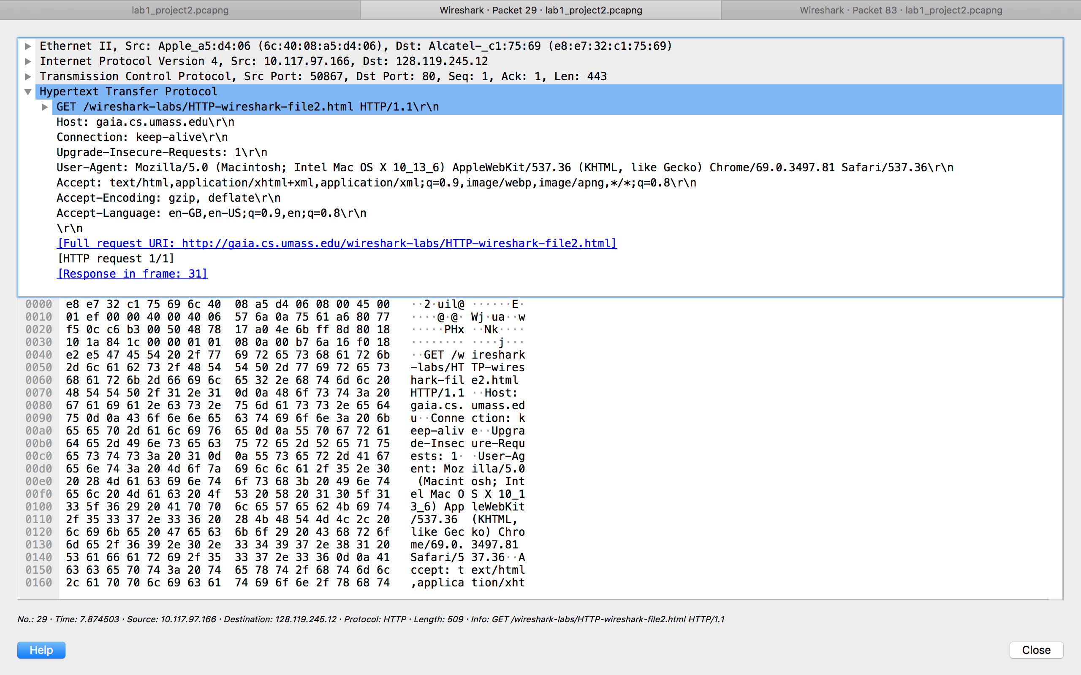

**Answer 9**

**Yes, the server returns the contents as we can see in the Line-based text data field.**

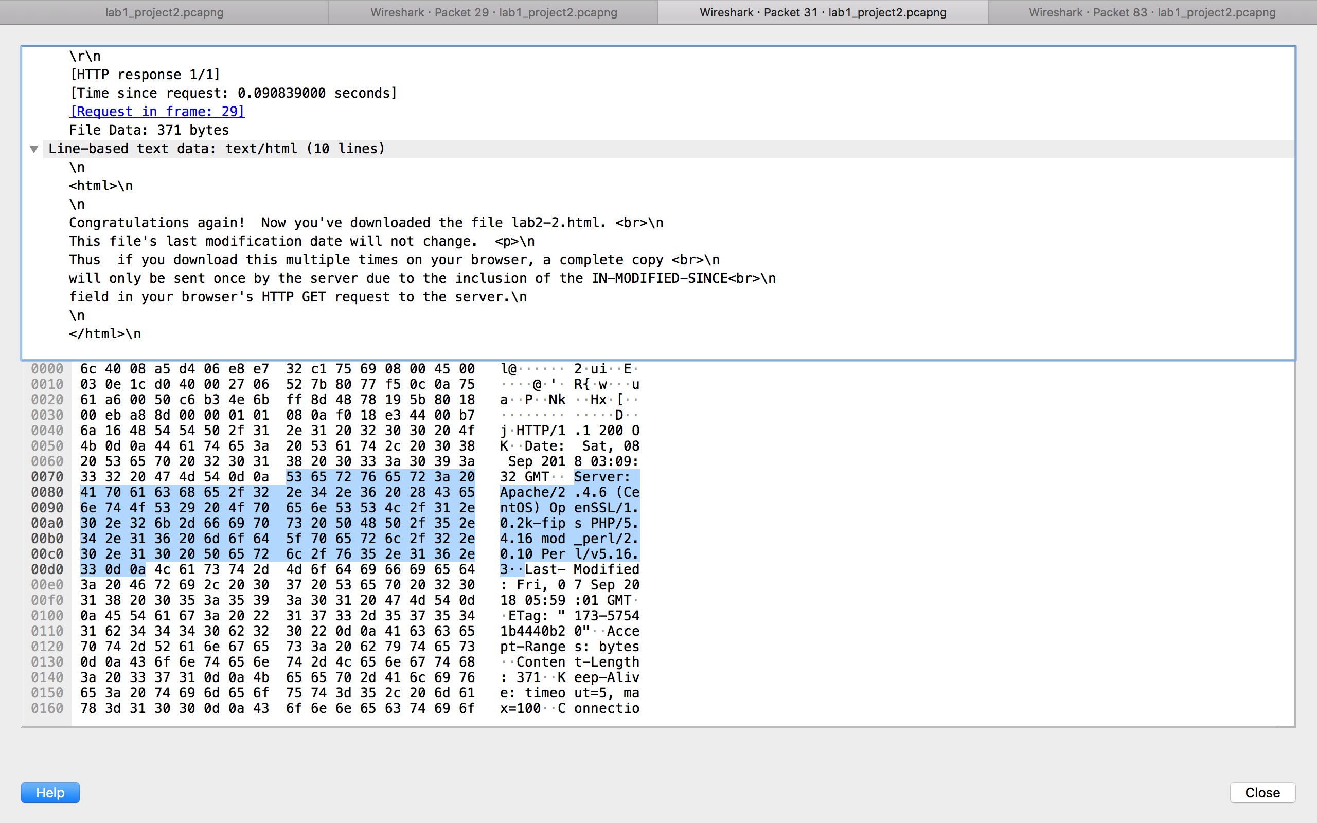

**Answer 10**

**The HTTP message contain an IF-MODIFIED-SINCE line. After IF-MODIFIED-SINCE I can see the date and time of last time I accessed the website or last modification of the file from the previous get request**

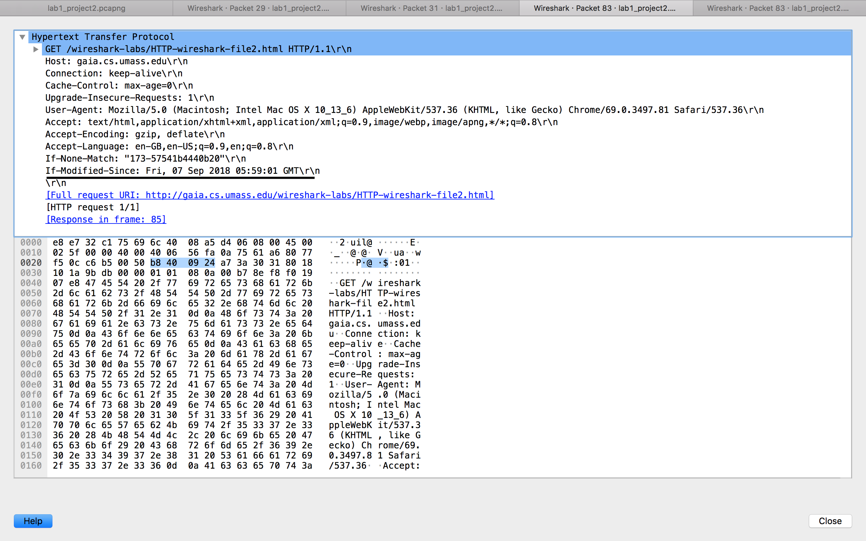

**Answer 11**

**The status code return from server is 304 Not Modified**

**The server doesn’t return the content from file as browser have it cache**

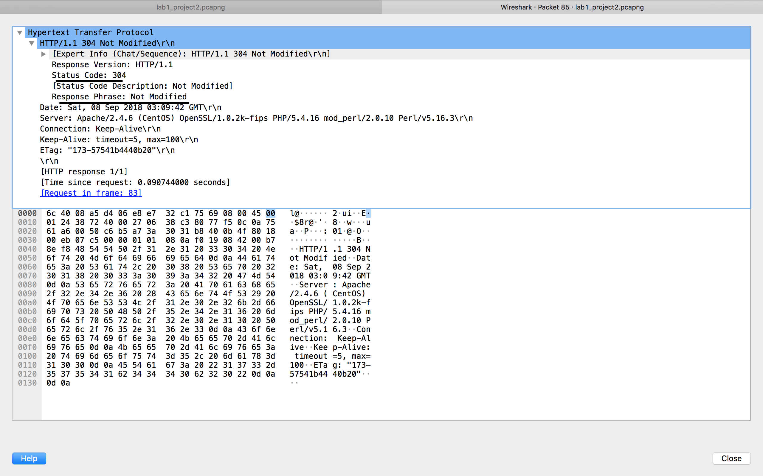

1. **Retrieving Long Documents**

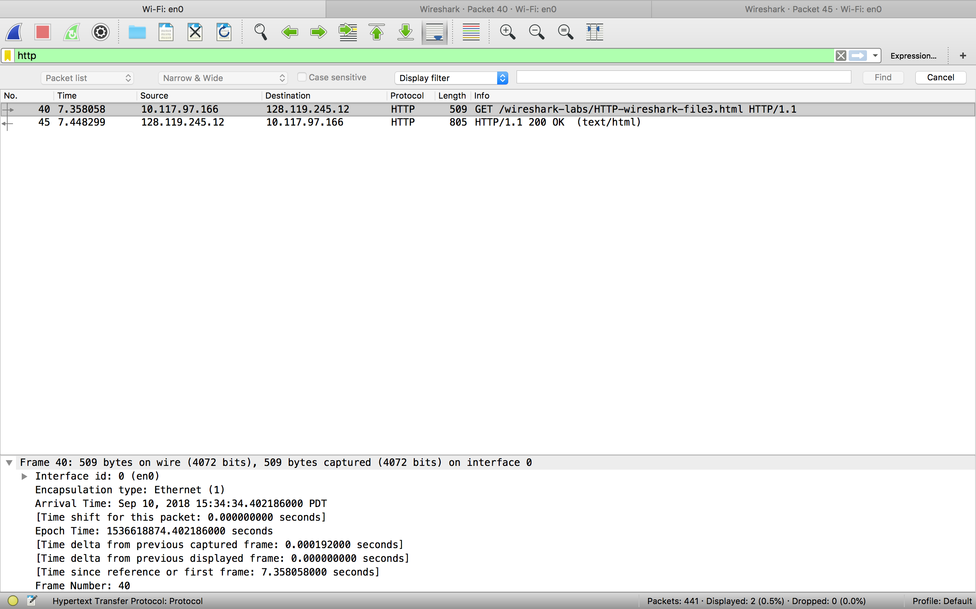

**Answer 12**

**One HTTP GET request have been send by my browser as you can in screenshot. Packet Number 40 contain the http GET message for the Bill or Right**



**Answer 13**

**The packet number 43 contain the status code and code which is send by the server in response to browser request**

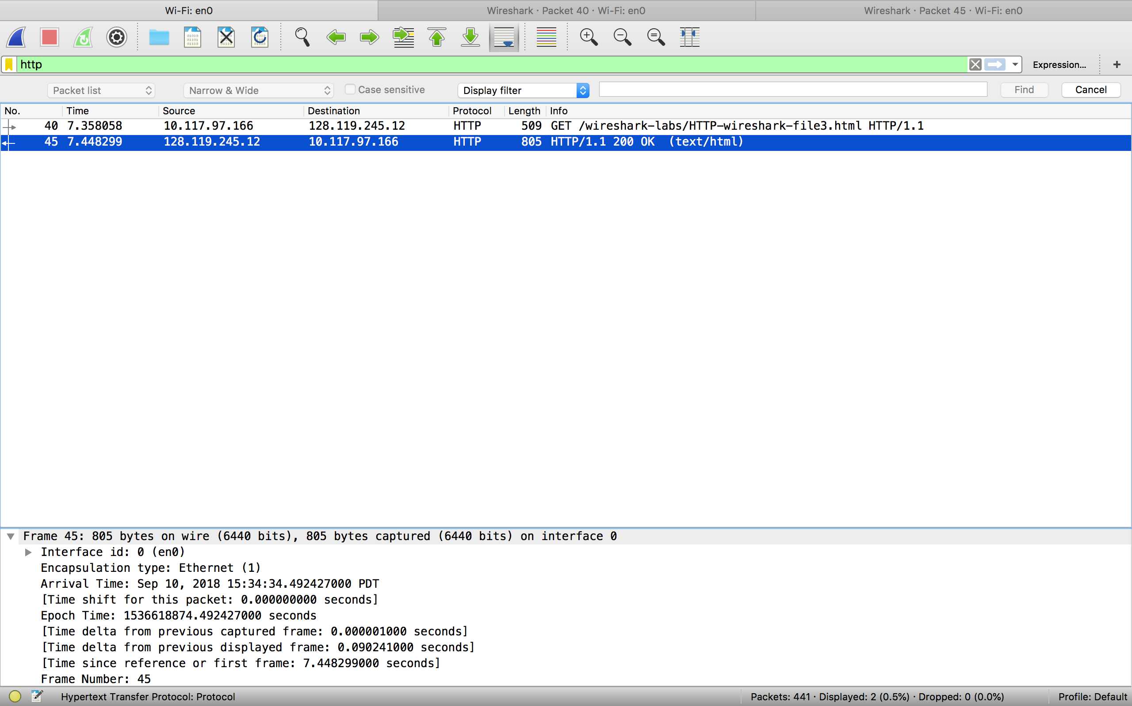

**Answer 14**

**The status code and phase is 200 Ok**

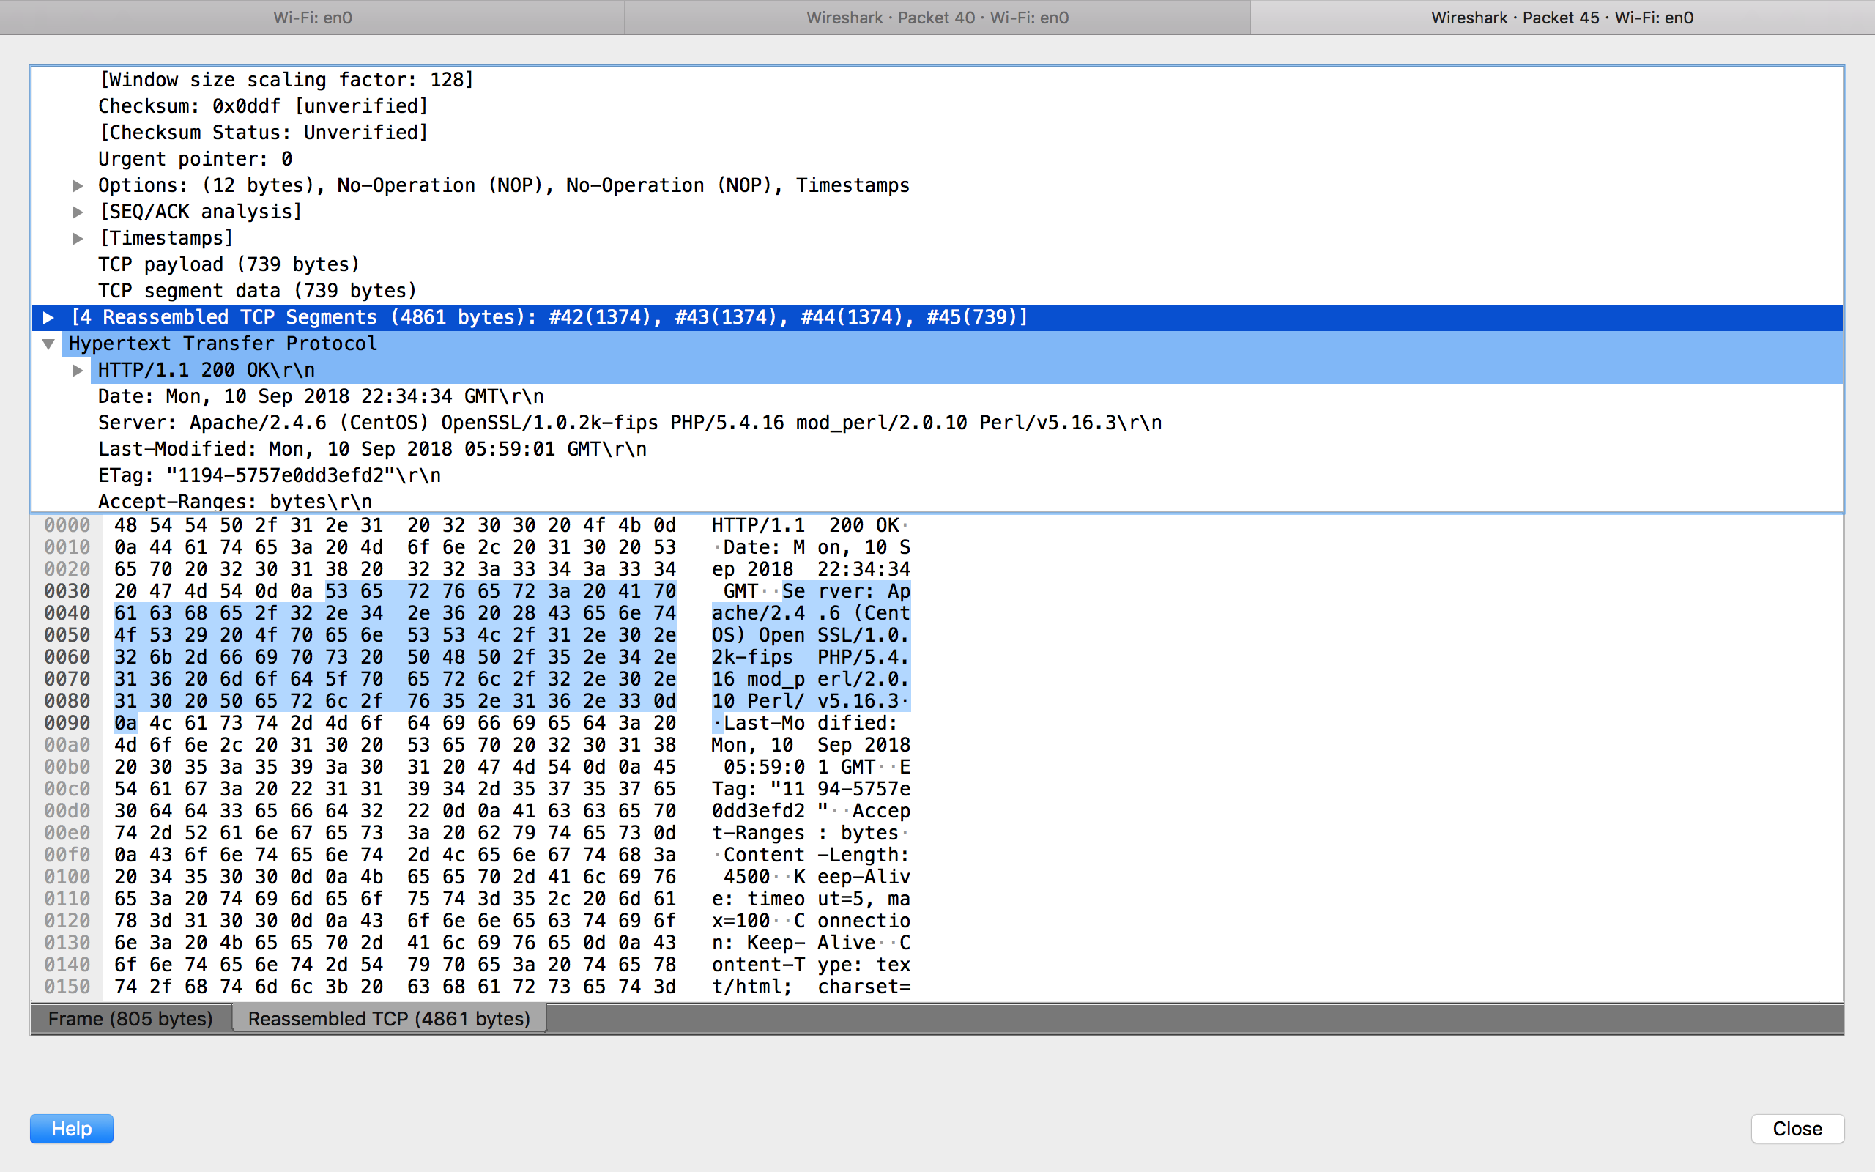

**Answer 15**

**Four data-containing TCP segments were needed to carry the single HTTP response and the text of the Bill of Rights**

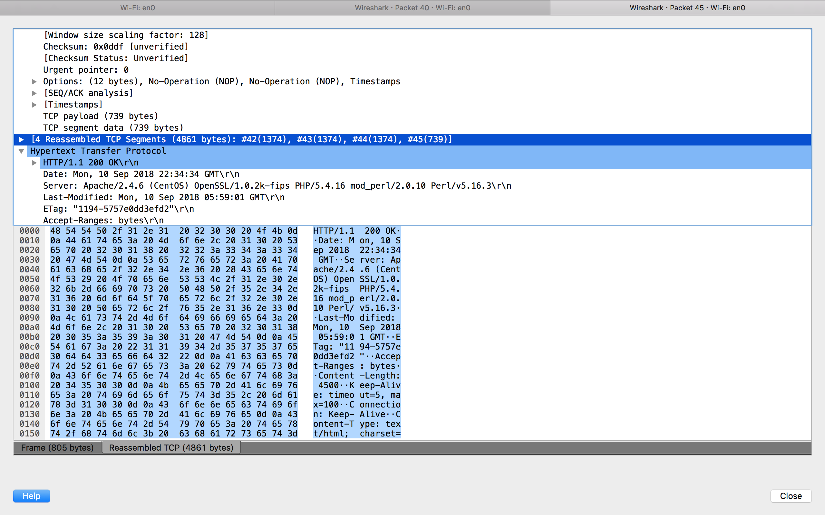

1. **HTML Documents with Embedded Objects**

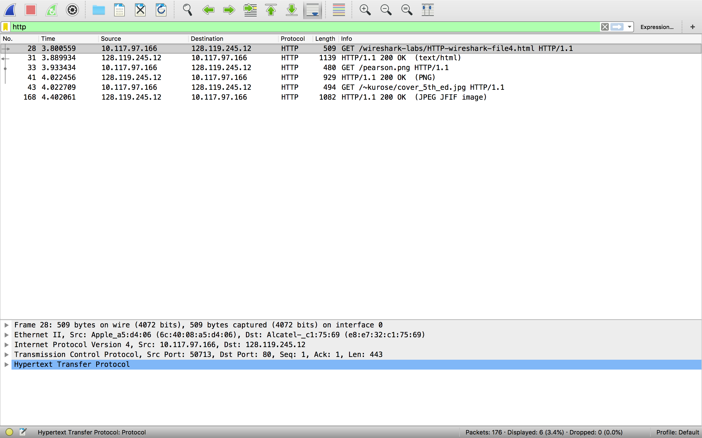

**Answer 16**

**Browser send 3 http get request**

**WebPage address : 128.119.245.12**

**Pearson png: 128.119.245.12**

**Kurose cover : 128.119.245.12**



**Answer 17**

**The browser downloaded two image serially as we can say this because the first image was request and was received then after the request of second image was made.**

**5 HTTP Authentication**

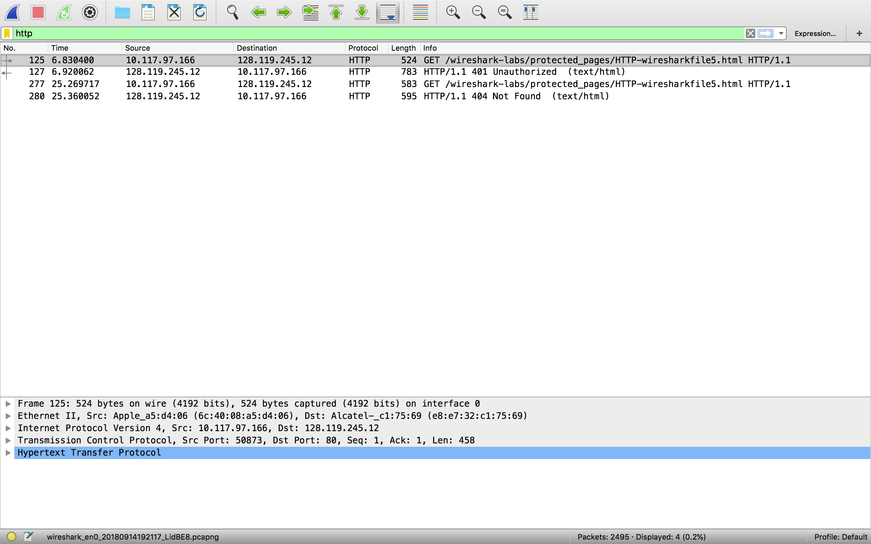

**Answer 18**

**The server initially response HTTP get Message from my browser is 401 unauthorized**



**Answer 19**

**The new field which is include in HTTP GET Message when browser second time send request to server is Authorization field because as we have send server our username and password in our first request so it notify that we are authorize user to use this webpage.**

